ENSE 281 Final Report

Goals:
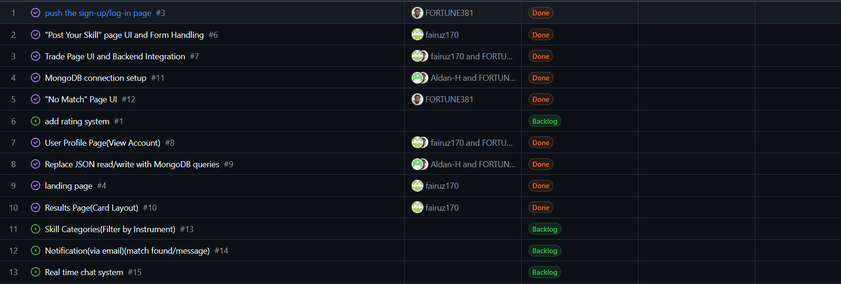
The initial idea we had after we met for our project was a website for people to share skills they know and learn a new skill in return via a trade system. Too many skills are very hard to learn on one’s own because it’s too expensive for lessons, or there is too much information to get started and people feel daunted, or existing free options don’t provide specific help for people who may be lost. We wanted to make a free website that allow users to list skills or hobbies that they know, and skills they wanted to know, and be able to post, trade and be welcomed in new communities online. These goals and their success can be seen on our kanban board.

Many of the initial goals were met, which is exciting. However, a few (most unfortunately the live chat system) we were unable to finish for this MVP due to time constraints, and we also had to lower the scope of the project a little. The lowering of the scope helped us a lot in managing the rest of the project because we were able to make a theme that worked with the idea we had.
Feedback:
We received a lot of really helpful feedback from each of the check-in periods. We were told that the original colour scheme and layout looked too corporate for a skill and hobby site, so we were able to change the theme to better fit a more casual learning environment. The idea for a user rating system came from feedback as well. Due to some problems that both were and were not our faults (more on that later), we also were advised to reduce the scope because an application for trading any two skills is a very large project, both from a mechanical and a logical perspective. Having any two skills being traded out of every skill ever would be a bit of a nightmare to both design and use, as it would be very hard for anyone to find someone with the right trade for them. From this, we reduced the scope down to just music, and SoundTrade is what we came up with. Limiting the skills to just music made it easier to rationalize from a designer’s perspective, but it also reduced the goal of engaging communities, because everyone who engages with the site is more or less a part of the same community, but it still provides engagement when some may not get much. For the final version of the project, the goals were refined to focus specifically on music skill exchange through the SoundTrade platform. This included enabling users to clearly define skills they can teach and skills they want to learn, improving the matching process, and ensuring that users could interact meaningfully through structured trades. By narrowing the scope, we were able to create a more focused and usable system that better aligns with real user needs. We also received feedback regarding system functionality and usability, particularly around simplifying the matching logic and improving navigation between pages. This helped us restructure parts of the application so that users could more easily understand how to interact with the system, especially when creating or responding to trade opportunities.

Process/Outcome:
The early idea gathering was difficult. We got the idea for what to make fairly early on, but we never really got together and ironed out the details, so the process early on was rough. We were able to get things figured out for activities one and two, but activity three was where our communication really became an issue. We had very little to present, and to top it off, one of our team members told us way too late that he had dropped the class, so we were also unprepared for that. Afterwards we met with Dr. Maciag and were able to find our footing and make something we could be proud of given the circumstances. The trading system works exactly as planned; we wanted to make it so you can only post if there are no matches to encourage users to interact with existing posts, and to avoid needless cluttering of the database. Moreover, we added the “Explore” tab so if users don’t have a particular interest, they can browse for posts that they can potentially trade with. On the technical side, we used Node.js and Express for the backend, and EJS for the frontend. We tried to follow a simple structure so everything wasn’t all over the place. That helped a lot once the project started getting bigger and we had more features to manage. One thing we did that we’re actually proud of is how we handled posting. Instead of letting users just post anything anytime, the system checks if there are already matches first. That way, people are encouraged to interact instead of just adding more and more posts that no one looks at.
Screenshots:
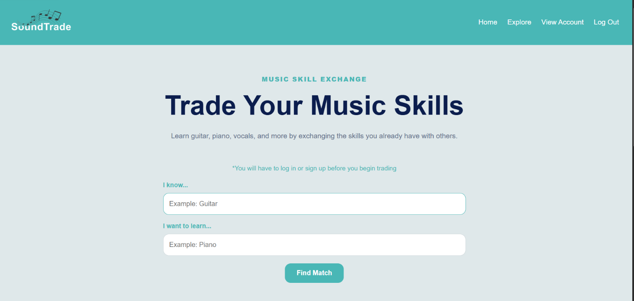
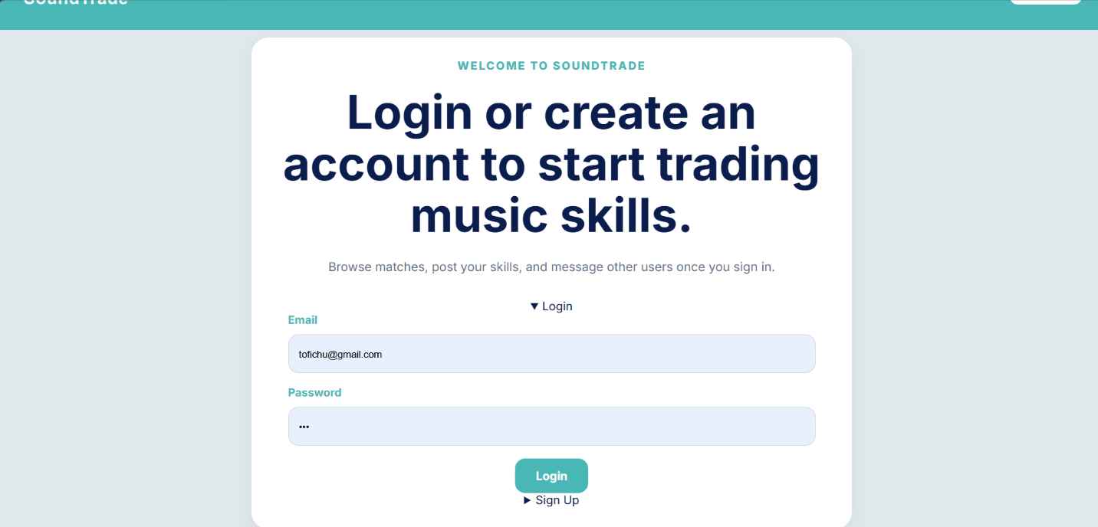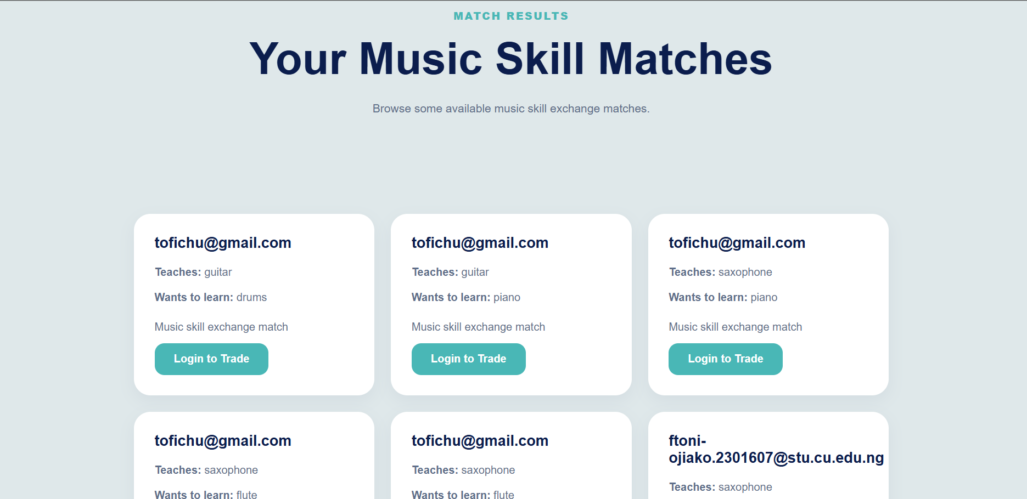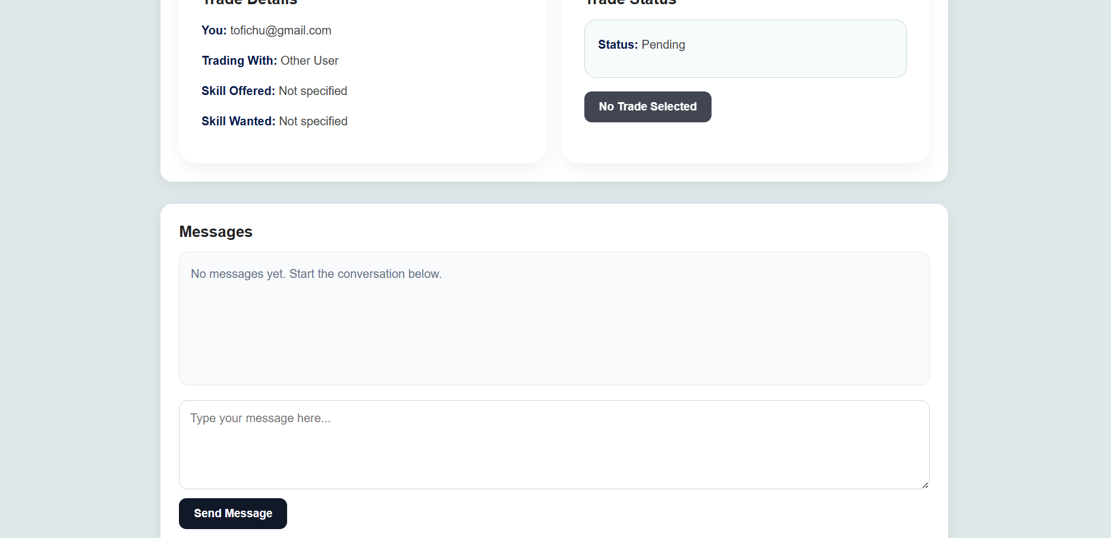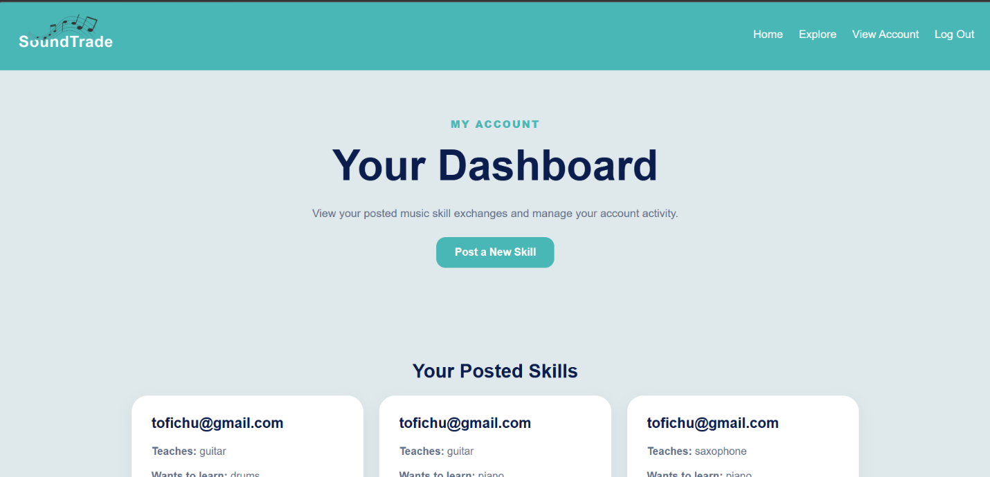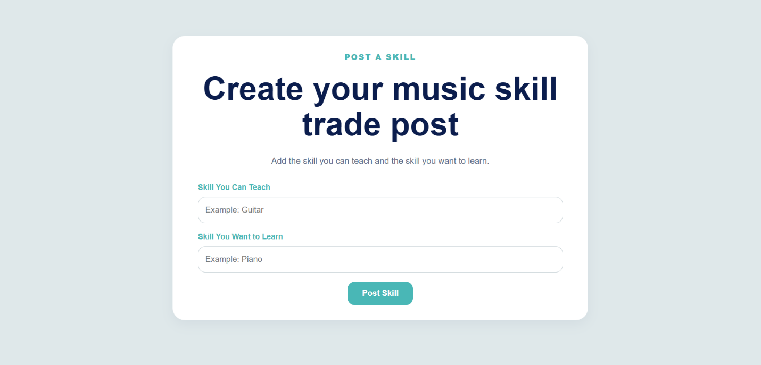
These screenshots show the main parts of our website, including how users post skills, find matches, and navigate through the platform. They give a better idea of how the final product actually looks and works.

Reflection:
Overall, this project was interesting. Once we got to working and we figured things out, the project was enjoyable. Apart from learning the applications and how to use them, which was very interesting, we learned about the importance of communication (the hard way) and how good communication makes any project go incredibly smoothly. We also learned that git is very useful for managing team planning, which makes the designing process easier. We are most proud of the fact that we were able to recover from our setbacks and make a finished product that was, while small, a full project of decent quality. As a whole, the project was a good way to introduce us to the process of designing a website. The information we were taught about the applications as well as the early design and ideas making/gathering was good to know going into the industry. There were a lot of documents that needed to be made for the project. In the end, this project taught us a lot, not just about building a website, but about working as a team. If we had better communication from the start, things would have gone a lot smoother. Still, we managed to pull everything together and create something we’re proud of.

